浙江省杭州市西湖高级中学2015届高三10月月考英语试题

第一部分：英语知识 （共两节，满分30分）
第一节：单项填空（共20小题 ;每小题0.5分，满分10分）
1. Browsing Taobao, _____ website that sells everything from mops to iphones, has become _____ daily routine for many Chinese people in recent years.
A．the; the B．a; the C．a; a D．the; /
2. ________，I have to put it away and focus my attention on study this week.
A．However the program is amusing B．No matter amusing the program is
C．However amusing the program is D．No matter how the program is amusing
3. She is already 70 years old, but she ________ as if she were still a little girl.
A．believes B．behaves C．directs D．declares
4.—Ladies and gentlemen, please remain ________until the bus has come to a complete stop.
A．seated B．seating C．to seat D．seat
5. —What do you suppose ________ her look so upset?
—________by her friends again.
A．made; She was misunderstood B．had made; Having been misunderstood
C．has made; Being misunderstood D．made; Misunderstood
6. At the Qiantang River, the tidal bore, a name for a large column of water，_____as high as 1.9 meters，________the start of the autumn flood period of the river.
A．reaching; marking B．reached; to mark C．reaching; to mark D．reached; marking
7. You can't jog _____ you like in the evening these days. Many areas are now not safe for girls.
A．whichever B．wherever C．what D．when
8. Out________，still discussing the Singer Wang Fen and his concert with great interest.
A．walked a crowd of young people B．did a crowd of young people
C．were walking a crowd of young people D．a crowd of young people were walking
9. Ebola is reported ________ in West Africa, which ________ worldwide attention.
A．being spread; attaches B．to be spread; attracted
C．having spread; attached D．to be spreading; attracts
10. The city of Hangzhou is so beautiful! I just love it.
--- Me too. The old cultural relics of the city are well ____________.
A．qualified B．persevered C．decorated D．simplified
11. The school offers a wide ________of subjects for the students to choose , which is exciting..
A．circle B．amount C．range D．quantity
12. More than 109000 Scottish teenagers aged 16 to 17 took part in the Scottish independence referendum(公民投票) , _______ Scotland eventually decided not to become independent.
A．which B．when C．that D．in which
13. We rent a beach house with two small rooms before the holiday，____can serve as a kitchen.
A．the smaller of which B．a smaller of which C．the smaller of them D．smaller of that
14. Give yourself 10% of ________ is left for your work and let me have the rest.
A．which B．that C．what D．where
15. _______is no possibility _______ she can catch the plane in two hours in such a rush hour..
A．There; that B．It; that C．There; whether D．It; whether
16. The boy _____ an A in the examination, but he was so careless as to make a foolish mistake.
A．must have gotten B. need have gotten C. could have gotten D. shall have gotten
17. _____all of us have become part of the group ____ we can really win the final.
A．It is only then ; that B．It is that；when C．It is only when; that D．It is when；when
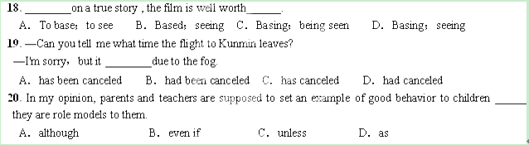
第二节：完形填空（共20小题; 每小题1分，满分20分）
Four years ago，I felt lucky after escaping one of those terrible 2mile runs. I hated __21__；it was just something that __22__ came easily to me. At that time，if you had told me that I would one day run a marathon，I'd have told you in all honesty that I had a better __23__ of winning the lottery (彩票)．
The turning __24__ came when I met Mrs. Green. She was fifty years old，going through chemotherapy (化学疗法) for her cancer，and still __25__ to run 30 miles a week. I __26__ that if Mrs. Green could run 6 miles at a time，I could run at least two. In February，in cold weather，I started to walk a 2mile __27__ around my neighborhood. Two months later，I __28__ the whole route，running for the first time. I felt exhausted，__29__ I felt happy.
Over the next several years，I continued to push each run for a few __30__ minutes，slowly building my endurance (耐力)．I didn't need to __31__ against other runners, for my most important competitor was myself.
After continuing to __32__ myself，I knew it was time to step my training up. I __33__ I would train for the Detroit Free Press/Flagstar Marathon.
The race day __34__ came，and I was filled with excitement and worry. It was final time to see what I was made of. The __35__ ended up incredibly. I did __36__ through the last few miles，but after my journey，there was no doubt in my mind that I'd finished. As I __37__ the finish line，I experienced the strongest sense of __38__ and happiness I had ever had in my life. I am now a marathoner.
As John Bingham once said，“The __39__ isn't that I finished. The miracle (奇迹) is that I had the __40__to start.”
21．A. studying B．thinking C．running D．teaching
22．A. never B．always C．usually D．often
23．A. chance B．belief C．suggestion D．hope
24．A. case B．point C．situation D．stage
25．A. devoted B．applied C．led D．managed
26．A. figured B．agreed C．proved D．ordered
27．A.race B．route C．site D．test
28．A. closed B．changed C．finished D．considered
29．A. and B．or C．so D．but
30．A. perfect B．extra C．actual D．basic
31．A. compete B．take C．rely D．argue
32．A. treat B．entertain C．march D．challenge
33．A. forced B．decided C．doubted D．seemed
34．A. certainly B．instantly C．finally D．regularly
35．A. moment B．atmosphere C．experience D．reward
36．A. struggle B．press C．break D．go
37．A. toured B．moved C．crossed D．stopped
38．A. touch B．pride C．humor D．award
39．A. miracle B．habit C．method D．plan
40．A. ability B．choice C．thought D．courage

第二部分：阅读理解(20小题，每小题2分，满分50分)
第一节：阅读下列短文，从每题所给的四个选项(A、B、C和D)中，选出最佳选项。
A
For most of his life，Daniel Defoe worked as a business man. However，when he was 60，he wrote something that was a great success. It was Robinson Crusoe，the first novel in English literature.
Why do we say that Robinson Crusoe was the first novel in English literature？Novels are fulllength invented stories. But even if the events and people in the story are invented，they are described in a way that makes them seem real. Before Robinson Crusoe，nobody in English literature had written a story like that. In Robinson Crusoe，Defoe describes Robinson's adventures in great detail. It seems that the writer is talking to the reader. In the early 18th century，most writers wrote in a complex style that was very different from the way people talked. Critics at the time didn't like the style of Robinson Crusoe. They didn't understand that Defoe had created something new in literature.
Robinson Crusoe is not only an exciting story but also a great novel. It makes the reader think about important questions about life. One interesting idea in the book is about the relationship between individuals and society. Robinson lives alone on an island. He is free to live in any way he wants，but he chooses to live as a civilized man. Another interesting idea in the book is how people need one another in society. On the island，there is nobody to help Robinson. He has to do everything by himself. He has to learn how to be a builder，a farmer and how to make clothes and shoes. This experience teaches Robinson how we all need the help of experts. Values are also discussed in the book. When Robinson goes back to the sunken ship，looking for things that could be useful，he picks up some gold and says，“This is no use to me.” He understands that something has value on condition that it is useful.
Robinson Crusoe was the first novel in English literature. It was also the first bestseller. When he wrote the story，Defoe changed English literature for ever.
41．From this passage，we know that Daniel Defoe ________.
A．showed his talents for writing when young
B．was the greatest novelist in English literature
C．was a merchant before he wrote Robinson Crusoe
D．wrote novels in his spare time
42．Which of the following is TRUE about Robinson Crusoe?
A．It was favoured by literary critics at that time.
B．It was based on a real story.
C．It opened a new era in English literature.
D．It was more a story than a novel.
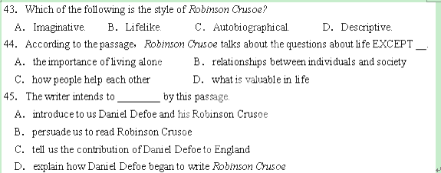
B
We all know that money can't buy happiness，but many times we act as if we were happier with a bit more money. We are conditioned to want to be rich(when we know the rich aren't happy either)；we are trained to want the latest gadget or style that television tells us to want；we want to earn more money because then we'll have a good life.
But none of them will bring us happiness. No matter how much we earn，no matter how much we have in the bank，no matter how nice our clothing or cars or toys，none of them will make us happier. And the sad thing is that it could take us decades to pursue wealth and luxurious items before we realize this.
So what will bring us happiness？Luckily，it's these three things that don't cost a thing. These three things have been proven by surveys of hundreds of thousands of people about what they have，what their lives are like，and how happy they are.
Here they are，the Three Secrets to Happiness：
1．Good relationships. We have a human need to be close to and to be intimate with other human beings. Having good and supportive friendships，a strong marriage or close and loving relationships with our family members will make us much more likely to be happy.
Action steps：Take time，today，to spend time with your loved ones，to tell them what they mean to you，to listen to them，and to develop your relationships with them.
2．Positive thinking. I'm obviously a big proponent of positive thinking as the best way to achieve your goals，and it turns out that it can lead to happiness too. Optimism and selfesteem are some of the best indicators of people who lead happy lives. Happy people feel empowered，take control of their lives，and have a positive outlook on life.
Action steps：Make positive thinking a habit. In fact，this should be one of the first habits you develop. Get into the habit of squashing all negative thoughts and replacing them with positive ones. Instead of “I can't” think “I can”．It may sound silly，but it works for me，every time.
3．Flow. This is a popular concept on the Internet these days—a state we enter when we are completely focused on the work or task before us. We are so buried in our task that we lose track of time. Having work and leisure that get you in this state of flow will almost undoubtedly lead to happiness.
People find greatest enjoyment not when they're passively mindless，but when they're absorbed in a mindful challenge.
Action steps：Find work that you have a passion for. Seriously—this is an extremely important step. Find hobbies that you have a passion for. Turn off the TV—this is the opposite of flow—and go outside and do something that truly engages you.
You've been given the Three Secrets to Happiness. Don't waste them!
46．Which of the following is the most proper title of this passage?
A．The Secrets to Happiness B．What is happiness?
C．Money vs Happiness D．Who are happy?
47．The writer expresses his ________ attitude towards money and wealth.
A．negative B．supportive
C．objective D．respective
48．Which of the following doesn't belong to the advice given by the writer?
A．Being engaged in what you are interested in. B．Having good relationships with others.
C．Watching TV. D．Being optimistic about your life.
49．The underlined word “squashing” can be replaced by “________”．
A．removing B．scolding C．repairing D．reducing
50．The writer talks about happiness by means of ________ in this passage.
A．opinions and advice B．facts and comparisons
C．examples and analysis D．observations and conclusions
C
“Reduce，reuse and recycle”，this popular environmental slogan tells us how to reduce the amount of rubbish that ends up in landfills.
The slogan is being used to deal with one possibly dangerous form of electronic junk，such as old computers，cellphones，and televisions. But this process of managing ewaste may be used in an unscrupulous way more often than not，a recent report suggests.
“Many of these materials are being sent to developing nations under the excuse for reuse—to bridge the digital divide，”said Richard Gutierrez，a policy researcher.
One of the problems is that no one proves whether these old machines work before they hit the seaways. Because of this，the report says，ewaste is a growing problem in Lagos，Nigeria，and elsewhere in the developing world. Much of the waste ends up being thrown away along rivers and roads. Often it's taken apart by poor people，who may face dangerous exposure to poisonous chemicals in the equipment.
Tradesmen also pay workers a little money to get materials back such as gold and copper. This lowtech recovery process could expose workers and the local environment to many dangerous materials used to build electronics. According to Gutierrez，this shadow economy exists because the excuse for recycling and reusing electronics gives businessmen “a green passport” to ship waste around the globe. “Developing nations must take on some of the responsibility themselves，”Gutierrez said. But he added，“A greater part of this responsibility should fall on the exporting state.”
China，for example，has become a dumping place for large amounts of ewaste. The nation is beginning to take action to stop the flow of dangerous materials across its borders. The Chinese government，after many years of denials，is finally beginning to take the lead.
51．The underlined word “unscrupulous” in the second paragraph most probably means “____”．
A．efficient B．profitable C．unbelievable D．dishonest
52．What does the fourth paragraph mainly discuss?
A．Old computers and TVs still work before they are sent abroad.
B．Poor people break up ewaste to collect some valuable materials.
C．A lot of ewaste is dumped in developing countries.
D．The problem of ewaste is growing in developing countries.
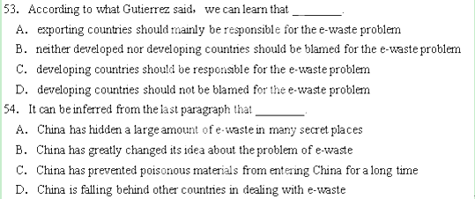
D
For years I fought with the bird's nest that sat on top of my head-my Medusa（神话中的蛇发女妖）hair．No matter what I did and how hard I tried, in no way could I make my unruly （乱蓬蓬）hair to my satisfaction．
Growing up in a Russian-Jewish home with parents who thought North American styling products were something illegal such as drugs, I was never allowed to put them in :my hair．¨ Why buy hair gel? Your hair is so beautiful naturally," my mother would say．The teens at school did not agree．From boys 'not wanting to kiss me when we played spin the bottle in Grade 7 to being called the mop, I suffered from my hair．
When I got to university, I believed my hair was a wall that stood between me and everything-finding a part-time job, getting a boyfriend, etc．
If only I could find a way to manage the curls and put it behind bars, I told myself, I would feel secure and sexy．I tried everything: rollers, hairspray, gels and, at one point, an iron．Then, in my second year, a miracle happened．I was asked to be a hair model for Japanese hair straightening, a process by which the molecules（分子）of my curls would be broken and reset in a bone-straight position．I was the perfect candidate, the hairdresser told me． Although they said how hair relaxing could damage the :scalp （头皮）,for the next five years I didn't find them to be true． All of the hairdresser's promises were fulfilled: With my hair straight and smooth, I was no longer the¨ mop"．
However, there was extreme damage done to my wallet．To keep up the straightening cost $ 700 every six months, and that was considered cheap．While some people thought I was crazy, I was willing to do anything to never again feel like that anxious, curly-headed girl in Grade 7．But when I moved out． of my parents" house 'at age 26 and rented an apartment, the upkeep of my new image became too costly．
I couldn't hide from my inner Medusa any longer．It was time to hug her and let her fly．Seeking a choice, I turned to the Internet, Google．After hours of searching, I hit upon a“ curly haired" salon, a place designed for girls like me．I doubted these so-called “Curl Ambassadors" could do anything without using machine of some sort, and though I bought the service called the “Curly-Doo," I suspected I'd have the same unruly mop at the end of the appointment．
I dragged my feet so hard getting there that I arrived 45 minutes late． I secretly hoped they would turn me away．Instead, my stylist simply said : ‘‘You are very late． Let me see your hair" At． that moment, my world and beliefs about myself were turned upside down along with my hair． As my head was in a basin full of freezing-cold water, then covered with a jelly-like jam, I wondered what I had got myself into．
¨ Do you really think this will work?" I asked the stylist, Jones．“ My curls are a disaster．"“No curly hair is hopeless," she replied．“They just haven't found a way to work with it, that's all．"
After the hour was over, Jones had completed her work． She had styled my hair using only her hands, water and a mixture of organic jam． I couldn't believe what I was seeing in the mirror: a naturally curly, Medusa-free me．You could argue that hair is just hair． Yet, it is just such physical features that have such a large influence on how we view ourselves．
According to Jones,75 percent of the population have a wave or curl in their hair and don't know what to do with it． Men cut theirs short． Women flat-iron theirs to death． When I read through a beauty magazine or take the subway to work, it makes me sad to see so many people repressing their natural beauty．
Since then, my world has changed． I have always been outgoing, but these days I seem to be more outspoken and confident than ever． On top of that, friends and co-workers tell me I am looking better than ever, but they don't know the source of the change．
I don't need to tell them* My Medusa hair speaks for herself．
55．What can we learn about the writer's hair in the first place?
A． Her parents considered it was bird's nest．
B． Teens at school laughed at it as Medusa hair．
C． She hated it because it couldn't be straightened．
D． North American styling products harmed her hair．
56．Japanese hair straightening caused a problem for the writer that ．
A． her wish to feel secure and sexy didn't come true
B． her hair was seriously damaged after the straightening
C． the cost to keep her hair straight was too high for her
D． she was called ¨the mop" with her hair straight and smooth
57．The writer was when she went to the “curly haired" salon．
A． hesitated B． excited C． disappointed D． determined
58．What was the reaction of the stylist in the salon when she saw the writer?
A． She was very angry because the writer was late．
B． She thought totally the writer's hair was a disaster．
C． She was calm and sure of her work．
D． She thought there was no way to fix the writer's hair．
59．The writer's world has changed because she ．
A． has removed her inner Medusa
B． has removed her curls on her head
C． has found a way to straighten her hair in the stylish salon
D． has found the admiration for her from her friends and co-workers
60．The best title of the passage can be ．
A． A Successful Stylist B． My Medusa Hair
C． Road to Beauty D． Accept the Way We Are

第二节：下面文章中有3处 (第61-～65) 需要添加小标题。请从（A、B、C、D）中选出符合各段意思的小标题， 并在答题纸上将相应选项的标号涂黑。
A. New teachers’ opinions of involving parents
B. An argument over an assignment
C. A conflict between assumption and reality
D. Difficulties in sharing goals
E. The best way to score high
F. Proper ways of parental involvement

61.

An Iowa high school counselor gets a call from a parent protesting the “C” her child received on an assignment. “The parent argued every point in the essay,” recalls the counselor, who soon realized why the mother was so disappointed about the grade. “It became apparent that she’d written it. ”
62.

In a survey, 90% of new teachers agreed that involving parents in their children’s education is a priority at their school, but only 25% described their experience working with parents as “very satisfying”. When asked to choose the biggest challenge they face, 31％ of them quoted involving parents and communicating with them as their top choice. 73％ of new teachers said too many parents treat schools and teachers as enemies.
63.

At a time when competition is rising and resources are limited, when battles over testing force schools to adjust their priorities, when cell phones and e-mail speed up the information flow and all kinds of private ghosts and public quarrels slip into the parent-teacher conference, it’s harder for both sides to step back and breathe deeply and look at the goals they share.
64.

Everyone says the parent-teacher conference should be pleasant, civilized, a kind of dialogue where parents and teachers build partnership. But what most teachers feel, and certainly what all parents feel, is anxiety and panic.
65.

When a teacher asks parents to be partners, he or she doesn’t necessarily mean Mom or Dad should be camping in the classroom. Research shows that though students benefit modestly from having parents involved at school, what happens at home matters much more. According to research based on the National Education Longitudinal Study, a sample of nearly 25,000 eighth graders, among four main areas of parental involvement (home discussion, home supervision, school communication, and school participation), home discussion was the most strongly related.

卷II 非选择题部分（共40分）
第一节：短文改错（共10小题；每小题1分，满分10分）
下面短文中有10处语言错误，请在有错误的地方增加、删除或修改某个单词。
Last week I went to visit to my former neighbor, Mr Yang. He and I used to living next to each other for many years. About half a year ago , an order came which the old building , along with many other similar ones, were going to be pulled down to make room for a main street.
So I had to move apart. Mr. Yang now lives in the suburbs near a beautiful park. His new apartment is much big than before. The only problem is that it took quite a long time to get to the downtown area. Therefore, Mr. Yang doesn’t seem to worry about the long distance. He says that new subway line is to be built in a few year and he is sure life will be better in the future.

第二节：句子翻译（共5小题，满分10分）[
66. 他因为在运动会上表现出色而获得最佳运动员称号。
_____________________________________________________________________________
67．她学习努力，从不迟到。---杰克也一样。
_____________________________________________________________________________
68. 据说空闲时做做瑜伽对健康又极大的好处。
_____________________________________________________________________________
69. 这首歌让她回想起了中学的美好岁月。
_____________________________________________________________________________
70. 孩子们发觉很难适应那里的新学校。
_____________________________________________________________________________
第三节：书面表达（共1小题，满分20分）
近期，你所在的城市就“最美汉字”进行投票。根据下面报道，请用英语写一篇短文向学校英文报“Happy Teens”专栏投稿。
The Chinese character ren, a word that generally means “benevolence”（仁）, has been selected by high school students in a poll (民意调查) to highlight Chinese culture around the world. The Character ren was selected by 8.22% percent of the 3000 respondents who took part in the poll, according to one of the organizers , a student from a high school. It was followed by the character ai, yi, meng and xiao, which mean “love”, “one”, “dream” and “filial piety”. Those characters ranked in the top 20 most beautiful Chinese characters”
------ China Daily
注意：词数：120左右, 作文中不得提及考生身份的任何信息，如班级，人名等。
1.简要概括学生推荐最美汉字的理由。2.简述你最想推荐的一至两个汉字以及寓意。
3.谈谈你的感想。
杭西高2014年10月考高三英语答卷
第一节：短文改错（共10小题；每小题1分，满分10分）
Last week I went to visit to my former neighbor, Mr Yang. He and I used to living next to each other for many years. About half a year ago , an order came which the old building , along with many other similar ones, were going to be pulled down to make room for a main street.
So I had to move apart. Mr. Yang now lives in the suburbs near a beautiful park. His new apartment is much big than before. The only problem is that it took quite a long time to get to the downtown area. Therefore, Mr. Yang doesn’t seem to worry about the long distance. He says that new subway line is to be built in a few year and he is sure life will be better in the future.

第二节：句子翻译（共5小题，满分10分）[
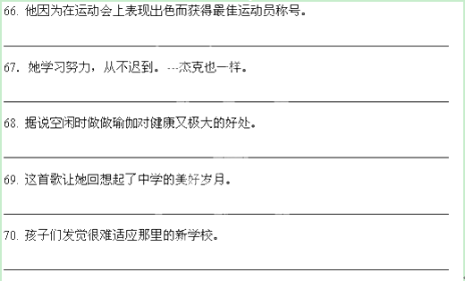
第三节：书面表达（共1小题，满分20分）

——————————————————————————————————————————————————————————————————————————————————————————————————————————————————————————————————————————————————————————————————————————————————————————————————————————————————————————————————————————————————————————————————————————————————————————————————————————————————————————————————————————————————————————————————————————————————————————————————————————————————————————————————————————————————————————————————————————————————————————————————————————————————————————————————————————————————————————————————————————————————————————————————————————————————————————————————————————————————————————————————————————————————————————————————————————————————————————————————————————————————————————————————————————————————————————————————————————————————————————————————————————————————————————————————————————————————————————————————————————————————————————————————————————————————————————————————————————————————————
杭西高2014年10月高三英语参考答案
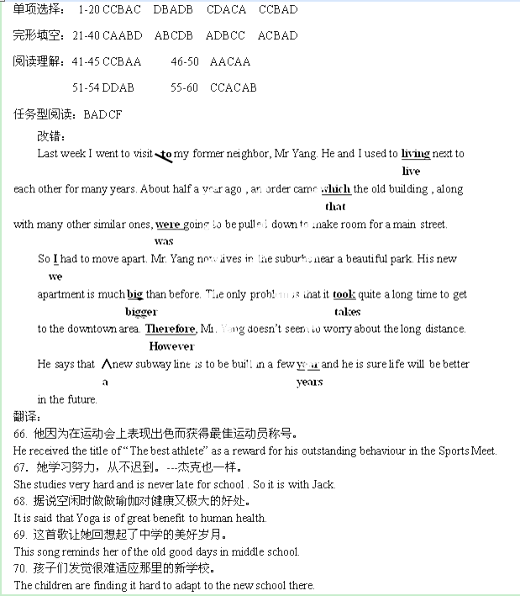
作文：
Recently, some high school students conducted a poll asking people to choose some Chinese characters that can best reflect Chinese culture.
Among tens of thousands of characters ,ren, ai, yi,meng, xiao are strongly recommended . Obviously, most students think the five characters carry typical Chinese culture in terms of traditional beliefs and core values concerning morality and ethics, which are principles and necessities for a qualified human being.
Of all characters , I will also put ren on the top of my list, which is followed by meng. Being ren, that is, being kind, caring and helpful , calls on one to be friendly and considerate to others. Holding meng, which means best wishes for the future, one is not only to seek for opportunities for a better life, but also to create brand new things for people around the world, feeling happy and optimistic.
Personally, Chinese characters are so charming that they are treasures of human cultures. With deep love for Chinese culture, we should strive to promote them to the world.

答案详解：
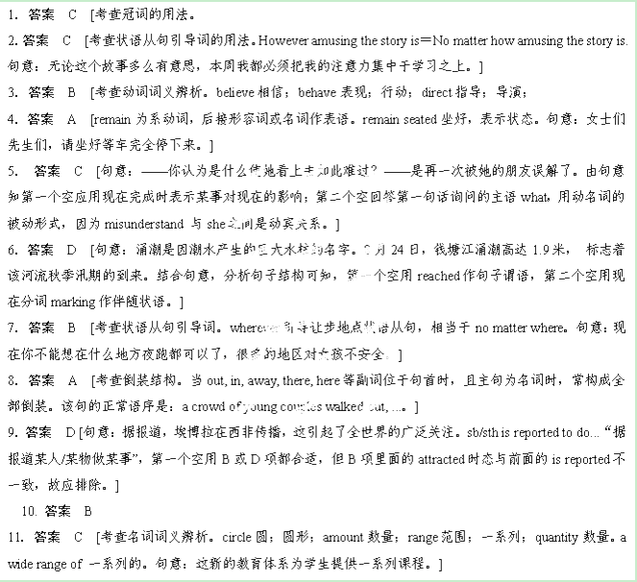12． 答案 D [考查定语从句的引导词。]
13．答案 A [考查定语从句的引导词。先行词为rooms，应用which引导；“the ＋比较级”表示两者之中“较……的那一个”。句意：我们租了一座有两个房间的海滨房，其中较小的那个房间可用作厨房。]
14．答案 C [考查宾语从句的引导词。从句中缺少主语应用what 引导。句意：你做剩余工作的10%，让我做其他的。]
15．答案 A [考查固定句式。that引导同位语从句修饰possibility。句意：她不可能在两个小时之内完成阅读。
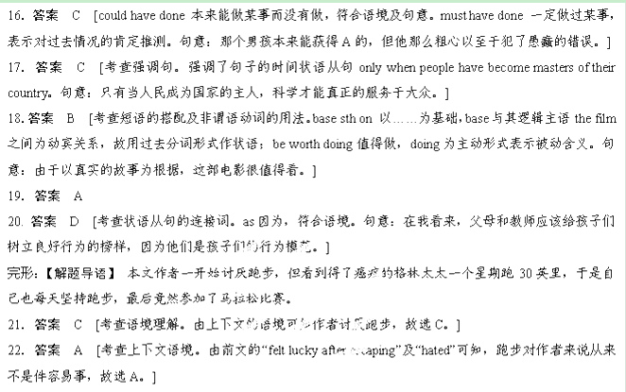
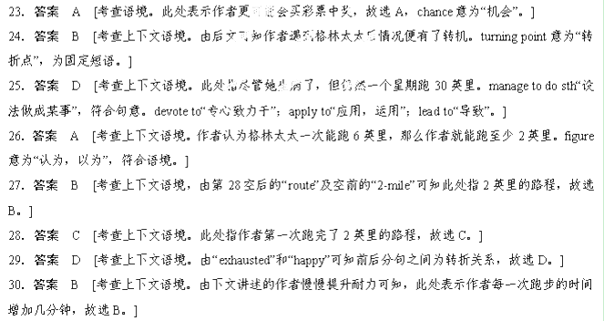31．答案 A [考查上下文语境。由后半句“for my most important competitor was myself.”可知此处应该是说作者不用与其他的跑步者竞赛。]
32．答案 D [考查上下文语境。由前文提到作者一次次地增加跑步的时间可知作者是在挑战(challenge)自己。]
33．答案 B [考查上下文语境。后文提到作者要去参赛，此处应该是作者的决定，故选B。]
34．答案 C [考查上下文语境。由语境可知，此处指出赛的日子最后(finally)到来了。]
35．答案 C [考查上下文语境。由38空前面的“experienced”可知这是作者的一次体验。]
36．答案 A [考查上下文语境。由语境可知，在最后的几英里路程上，作者的确努力了。struggle意为“奋斗，努力”，符合语境。]
37．答案 C [考查常识。由常识可知，比赛时我们通常说穿过终点线，故选C，cross意为“穿过”，符合语境。]
38．答案 B [ 考查常识。穿过终点线后，作者应该感到自豪(pride)，故选B。]
39．答案 A [考查上下文语境。由最后一句话中的“The miracle”可知此处意为“奇迹不是我完成了(某事)”。]
40．答案 D [考查上下文语境。此处意为“奇迹是我有勇气(courage)开始”，故选D。]

阅读：
A篇【解题导语】 你知道英国文学中“历险小说”的开创者是谁吗？这种历险小说为什么会受到历代读者的青睐呢？一起来了解一下英国第一位伟大的小说家吧！
41．答案 C [细节理解题。从第一段可知，丹尼尔·笛福一直是一位商人，60岁时才开始写《鲁滨逊漂流记》，而且一举成名，故C项为正确答案。]
42．答案 C [细节理解题。根据第二段中的“Critics at the time didn't like the style of Robinson Crusoe.”可知当时的文学评论家并不喜欢《鲁滨逊漂流记》，故A项错误。根据第二段中的“Novels are fulllength invented stories”可知故事和人物都是虚构的，故B项错误。根据第二段中的 “Before Robinson Crusoe，nobody in English literature had written a story like that.”可知在这部小说之前，没有任何一部同类风格的小说，所以说《鲁滨逊漂流记》是英国文学史上第一部真正的小说，故C项是正确答案。D项的意思是“与其说《鲁滨逊漂流记》是一本小说，不如说是一个故事”，这与文章的相关内容不一致。]
43．答案 B [推理判断题。根据第二段可知，《鲁滨逊漂流记》被称为英国文学史上的第一部小说是因为在此之前没有一部类似风格的小说，这部小说给我们的感觉是真实的，就好像是小说中的人物在与你谈话，所以选择B项。用lifelike描述这部小说的风格最合适。]
44．答案 A [细节理解题。第三段介绍了《鲁滨逊漂流记》中蕴含的生活中存在的几个问题：个人与社会之间的关系，如何相互帮助，生活中什么是有价值的。由此可知A项没有提到。]
45．答案 A [作者意图题。本文第一段已点明了主题，最后一段又进一步呼应主题，即丹尼尔·笛福和他的《鲁滨逊漂流记》。]
B篇；【解题导语】 本文是一篇议论文。作者阐述了金钱和财富不会给人们带来幸福的观点，同时就如何得到幸福这个问题给我们提供了三个秘诀。
46．答案 A [标题归纳题。本文第三段中的第一句“So what will bring us happiness？”已点明了主题，最后一段中的“You've been given the Three Secrets to Happiness.”又再次点明主题。故选A。]
47．答案 A [作者态度推断题。根据第一段和第二段的内容可知，作者认为金钱和财富不会给我们带来幸福，更糟糕的是，往往是在追求金钱和财富几十年后我们才认识到这一点。A项“否定的”符合题意。]
