英 语 试 卷
本试卷分为第Ⅰ卷（选择题）和第Ⅱ卷（非选择题）两部分.共150分，考试时间120分钟.
第I卷 选择题部分 （共110分）
第一部分：听力（共两节，满分30分）
第一节（共5小题；每小题1．5分，满分7．5分）
听下面5段对话。每段对话仅读一遍。
1.What does the woman mean ?
A. She wished to take another cup of coffee.
B. She kept awake for two hours.
C. She slept badly last night.
2.What does the man mean?
A .He doesn't like to eat breakfast.
B. He is always late for work.
C. He is very busy.
3.What can we learn from the conversation?
A. Harvey is talkative. B. John is terrible . C. Harvey is quiet.
4.What are the speakers mainly talking about ?
A. Job expectations B. A car factory C. Job experiences
5.Who does the man want to go with ?
A. Tom B. Jenny C. Betty
第二节（共15小题，每小题1.5分，满分22.5分）
听下面5段对话或独白。每段对话或独白读两遍。
听第6段材料，回答第6至8题。
6. What does the man like doing?
A. Working weekends. B. Speaking with foreigners. C. Travelling and meeting people.
7. Which foreign language can the man speak well.
A. Japanese B. Chinese C. French
8. Where does the conversation probably take place ?
A. In an office B. In a classroom. C. In a shopping center
听第7段材料，回答9 至11题
9. Where did the man work after he graduated from high school ?
A.In a company B. In a lab . C. In a hospital .
10. How old was the man probably when he got his PHD?
A. 16 B. 28 C. 36
11. When did the man begin his research on the AIDS drug?
A. When he worked in a lab. B. When he was at night school. C. When he worked at a company.

听第8段材料，回答12 至14题
12.What can we learn about the man ?
A. He is a hotel manager.
B. He is a patient of Doctor Watson.
C. He has something wrong with his ears.
13.Where is Doctor Watson now ?
A. In the hospital B. In his house. C. At a conference.
14.When can the man see the doctor?
A. In the afternoon. B. At noon. C. In the morning
听第9段材料，回答15 至17题
15.What is troubling the woman ?
A. A headache B. A fever C. Sleeping problems
16.What do we know about the woman?
A. She runs her own company.
B. She works too much.
C. She is a manager.
17.What does the man advise the woman to do?
A. Work in the day . B. Change her job. C. Take a holiday.
听第10段材料，回答18 至20题
18.What will the weather be like in the northeast tomorrow?
A. Dry and windy B. Cold. C. Wet
19.Which area will be sunny tomorrow?
A. East China . B. Southwest C. Northeast.
20.What will the weather be like in the southwest tomorrow afternoon?
A. Foggy. B. Clear. C. Cloudy
第二部分：英语知识运用（共两节，满分30分）
第一节：单项填空（共20小题；每小题0.5分，满分10分）
从每题所给的A、B、C、D四个选项中，选出可以填入空白处的最佳选项，并在答题卡上将该项涂黑。
21. ------ Mary, is this your pen?
------ No, mine is bigger, ________ with a blue cap.
A. it B. one C. which D. that
22. The expert insisted that silkworms were first raised by a woman in_______ is now Hebei Province.
A. which B. what C. where D. that
23. It’s said that there are plenty of hotels in Wu Yi Shan. There _____ be any difficulty for you to find somewhere to stay.
A. wouldn’t B. mustn’t C. shouldn’t D. needn’t
24. Jack denied_______to the police as a suspect and insisted that he was innocent .
A. to take B. to be taken C. taking D. being taken
25. The book is of great value. ______ can be enjoyed from it until you have a deep understanding of it, however.
A. Anything B. Something C. Much D. Little
26. —Mr. Smith, you’re fine for over-speeding. Please sign here.
—For what? ________
A. Are you all right? B. I’m a foreigner. C. You can’t be serious. D. It doesn’t matter.
27. In the last years we have planted thousands of young trees on the hill around our village, _______ two thirds are pine trees.
A. which B. where C. of which D. in which
28. _______the city center ,we saw a stone statue of about 10 meters in height
A. Approaching B. Approached C. To approach D . To be approached
29. —I serve Jim three meals every day and do almost everything for him, but he still fails me.
—I’m sorry to say that’s ______ you are mistaken.
A. how B. why C. what D. where
30. ----I have a favor to ask you.
----_______ .
A. It’s a pleasure B. Go ahead C. Ask, please D. Help yourself
31. —There’s somebody at the door, Mr. Wilson.
—Tell ______ I’m out.
A. it B. him C. them D. somebody
32. —I went to the seaside and got plenty of rest.
—_______ You looked tired the last time I saw you.
A. I hope so. B. I am glad you did . C. Really? D. That sounds nice.
33. In a way I can see what you mean, even though I don’t ______ your point of view.
A. agree B. permit C. recognize D. share
34. Faced with a bill for $10,000, _______.
A. an extra job has been given to John B. the boss has given John an extra job
C. an extra job has been taken D. John has taken an extra job
35. It is difficult to imagine his _______ the decision without any consideration.
A. to accept B. accept C. accepting D. accepted
36. After several rounds of competition, the little girl because of her excellent English.
A. put out B. picked out C. broke out D. stood out
37．Even the white collars in big cities know that, high as their income is, they still can’t afford a new house ______．
A．physically B．personally C．economically D．accidentally
38．With the development of science, more new technology _____ to the field of IT.
A．has introduced B．is being introduced C．is introduced D．was introduced
39．The police are trying to find out the ______ of the woman murdered in the bathroom．
A．evidence B．characteristic C．status D．identity
40．Exhausted from a day's journey, the drivers ______ a motor hotel and put up there for the night．
A．knocked into B．pulled into C．broke into D．forced into
第二节：完形填空（共20小题；每小题1.分，满分20分）
阅读下面短文，掌握其大意，然后从41~60各题所给的四个选项（A、B、C和D）中，选出可以填入空白处的最佳选项，并在答题卡上将该项涂黑。
I first went to hear a live rock concert when I was eight years old. My brother and his friends were all 41 of a heavy metal group called Black Wednesday. When they 42that Black Wednesday were going to perform at our local theatre, they all bought 43 for the performance. However, at the last minute, one of the friends couldn't go, so my brother44 me the ticket. I was really 45 !
I remember the buzz（嘈杂声）of excitement inside the theatre as we all found our 46 After a few minutes，the lights went down and everybody became 47 .I could barely make out the stage in the48.We waited. Then there was a roar from the crowd, like an explosion, as the first member of the band 49 the stage. My brother leaned over and shouted somethings in my ear, but I couldn't 50 what he was saying. The first song was already starting and the music was as 51 as a jet engine. I could 52 the drum beats and the bass notes in my stomach.
I can’t recall any of the songs that the band played. I just 53 that I really enjoyed the show and didn't want it to 54 .But in the end, after three encores（加演）, the show finished. We left the 55 and walked unsteadily out onto the pavement. I felt a little dizzy, as if I had just 56 from a long sleep. My ears were still 57 with the beat of the last song. After the58, I became a Black Wednesday fan too for a few years before getting into other kinds of music. Once in a while, 59, I listen to one of their songs and 60 I’m back at that first show.
41. A. members B. friends C. fans D. volunteers
42. A. guessed B. discovered C. thought D. predicted
43. A. flower B. drinks C. clothes D. tickets
44. A. looked B. offered C. returned D. found
45. A. relaxed B. embarrassed C. excited D. encouraged
46. A. seats B. entrance C. spots D. space
47. A. comfortable B. quiet C. serious D. nervous
48. A. silence B. noise C. darkness D. smoke
49. A. fell upon B. got through C. broke into D. stepped onto
50. A. forget B. hear C. repeat D. bear
51. A. loud B. hard C. sweet D. fast
52. A. feel B. touch C. enjoy D. digest
53. A. realize B. understand C. believe D. remember
54. A. continue B. delay C. finish D. change
55. A party B. theatre C. opera D. stage
56. A. escaped B. traveled C. benefited D. woken
57. A. aching B. burning C. ringing D. rolling
58. A. competition B. performance C. interview D. celebration
59. A. though B. otherwise C. instead D. besides
60. A decide B. regret C. conclude D. imagine
第二部分：阅读理解（第一节 20小题；第二节 5小题，满分50分）
第一节：阅读下列短文，从每题所给的四个选项（A、B、C和D）中，选出最佳选项。
A
I am Sergey Brin! I was born in Moscow. In 1979,when I was 5, my family immigrated to California, USA . I remember that on my 9th birthday, I got my first computer “Commodore 64”.
Later I graduated with honors in the University of Maryland in Mathematics and IT. The main field of my science research was the technologies used to collect data from unsystematic sources as well as large quantities of texts and science data. I was the author of dozens of articles in leading American academic magazines.
The greatest event in my life happened when in 1998 I was preparing for the defense(论文答辩) of my Doctor’s degree in the Stanford University. There the fate made me meet Larry Page—a young computer genius. Larry belonged to the intellectual society. I and Larry quickly became friends when we were working together.
We were searching day and night on the Internet. We were finding a lot of information but with the feeling we still couldn’t find enough of what we were looking for . Naturally the idea for a search engine that would allow specific information to be found in the endless pool of data was born like it came to us. It wasn’t our plans but we gave up the education at the university. You know the next part ,maybe—we managed to turn an ordinary garage in Peplo Park, California , the USA into our first office, in which Google was born. With excitement we typed the name of the thing which we created with love on September 14th,1998—www.Google.com. Now after those years we bought this garage. As a symbol it will always remind us that everything is possible.
61. Which of the following would be the best title for this passage?
A．The Birth of Google | B．The Founder of Google
C．The Importance of Cooperation | D．The Great Contribution to the Internet
62. From the passage we know that Larry Page________.
A．was born from a rich merchant family
B．was once a student in the Stanford University
C．published some academic articles when young
D．was Brin’s important partner in starting Google
63. Why did they found Google ?
A．Because they loved working with the Internet so much.
B．Because they wanted to make a lot of money through the Internet
C．Because they hoped to make it easy to find specific information online
D．Because they believed everything is possible.
64. Which is the right order of what happened ?
a. My family moved from Russia to the USA
b. I met Larry Page
c. I was given a computer as a present on my 9th birthday.
d. google was born in an ordinary garage in California.
e. I graduated from the university in Mathematics and IT.
A．a-c-e-b-d | B．c-a-b-e-d | C．a-c-b-d-e | D．c-b-a-e-d
B
When you are little, the whole world feels like a big playground. I was living in Conyers, Georgia the summer it all happened. I was a second grader, but my best friend Stephanie was only in the first grade. Both of our parents were at work and most of the time they let us go our own way.
It was a hot afternoon and we decided to have an adventure in Stephanie’s basement. As I opened the basement door, before us lay the biggest room, full of amazing things like guns, dolls, and old clothes. I ran downstairs, and spotted red steel can. It was paint. I looked beyond it and there lay even more paint in bright colors like purple, orange, blue and green.
“Stephanie, I just found us a project for the day. Get some paintbrushes. We are fixing to paint.” She screamed with excitement as I told her of my secret plans and immediately we got to work. We gathered all the brushes we could find and moved all of our materials to my yard. There on the road in front of my house, we painted bit stripes (条纹) of colors across the pavement (人行道). Stripe by stripe, our colors turned into a beautiful rainbow. It was fantastic!
The sun was starting to sink. I saw a car in the distance and jumped up as I recognized the car. It was my mother. I couldn’t wait to show her my masterpiece. The car pulled slowly into the driveway and from the look on my mother’s face, I could tell that I was in deep trouble.
My mother shut the car door and walked towards me. Her eyes glaring, she shouted, “What in the world were you thinking? I understood when you made castles out of leaves, and climbed the neighbors’ trees, but this! Come inside right now!” I stood there glaring hack at her for a minute, angry because she had insulted (侮辱) my art.
“Now go clean it up!” Mother and I began cleaning the road. Tears ran down my cheeks as I saw my beautiful rainbow turn into black cement.
Though years have now passed, I still wonder where my rainbow has gone. I wonder if, maybe when I get older, I can find my rainbow and never have to brush it away. I guess we all need sort of rainbow to brighten our lives from time to time and to keep our hopes and dreams colorful.
65. What did the writer want to do when his mother came home?
A. To introduce Stephanie to her. B. To prevent her from seeing his painting.
C. To put the materials back in the yard. D. To show his artwork to her.
66. In his mother’s eyes, the writer_______.
A. was a born artist B. always caused trouble
C. was a problem solver D. worked very hard
67. The underlined word “rainbow” in the last paragraph refers to ______.
A. the rainbow in the sky B. the stripes on the pavement
C. something imaginative and fun D. important lessons learned in childhood
68. It can be learned from the passage that parents should ________.
A. encourage children to paint
B. value friendship among children
C. discover the hidden talent in children
D. protect rather than destroy children’s dreams
C
Maybe it is true that we do not know what we have got until we lose it, but it is
also true that we donot know what we have been missing until it arrives.
It takes an hour to like someone, and a day to love someone, but it takes a
lifetime toforget someone. Giving someone all your love is never an assurance that
they will love you back. Do not expect love in return; but if it does not, be
content it has grown in yours. Do not rely on one's appearance; it can trick you.
Do not rely on wealth; even that fades away. Rely on someone who makes you smile,
because it takes only a smile to make a dark day seem bright.
There are moments in life when you miss someone so much that you just want to pick
them from your dreams and hug them. Dream what you want to dream; go where you want
to go; be what you want to be, because you have only one life and one chance to do
all the things you want to do.
The brightest future will always be based on a forgotten past. You cannot go on
well in life until you let your past failures and heartaches go off. May you have enough
happiness to make you sweet, enough trails to make you strong, enough sorrow to
keep you human, enough hope to make you happy. The happiest of people do not
necessarily have the best of everything; they just make the most of everythingthat
comes along their way. Happiness waits for those who cry, those appreciate the
importance of people who have touched their lives. Always put yourself in others'
shoes. If you feel that it hurts you, it probably hurts the other person, too.
When you were born, you were crying and everyone around you was smiling. Live your
life so that when you die, you are the one who is smiling and everyone around you is
crying.
69. In this passage, the writer wants to tell us ______.
A. what to do in our life B. where to go with other persons
C. how to get on well with other persons D. how to treat our life
70. Which of the following statements is true according to the passage?
A. We often don't know what we have lost until it comes someday.
B. If you give someone your love, you are sure to receive love in return.
C. It is wise not to rely on anybody because you are likely to be deceived.
D. If it takes you a short time to love someone, you will easily forget the person.
71. If you put yourself in another person's position, ______.
A. you should put on other people's shoes B. you shouldn't do what will hurt other people
C. you should believe in other people D. you should depend on your imagination
72. In the last paragraph the writer is actually telling us that a person in the world
should be one who ___.
A. can accept the suggestions made by others
B. can live happily and forget the past
C. has made a lot of money for himself before he dies
D. does good for other people and is respected and loved by them
D
What's On Stage
An acrobatic（杂技） show: To celebrate its 50th anniversary, the China Acrobatic
Troupe (剧团) will present "The Soul of China", where the seemingly impossible is
made real. Chill（寒战）s will run down your spine(脊柱) as you watch breathlessly as performers take their art and their bodies to the edge.
Time: 7:30 p.m., September 13-19
Place: Capital Theatre, 22 Wangfujing Dajie, Dongcheng District
Exhibitions
Joint Show: A group ink painting exhibition is running at the Huangshicheng Art
Gallery in Beijing. About 50 works by 25 young artists including Ge Yun and Yu Yang
are on display.
Time: 9:00 a. m.-5:00 p.m. until September 10
Place: Huangshicheng Art Gallery, 136 Nanchizi Dajie, Dongcheng District
Oil paintings:
The Wanfung Art Gallery will host a joint show of oil painting by 10 young and middle
-aged artists. On display are more than 30 of their latest works, which capture
（捕捉）the wondrous variety of life in unique styles.
Time: 9:00 a.m. -4:00 p.m. until September 15
Place: 136 Nanchizi Street, Dongcheng District
Literature museum: The National Museum of Modern Chinese Literature offers an in-depth
study of the evolution of Chinese contemporary literature from 1919 to
1949.
Time: 9:00 a.m.-4:00 p.m., daily
Place: 45 Anyuan Donglu, Chaoyang District (Shaoyaoju area)
Concerts
Beijing rocks: "The Fashion Night of Chinese Rock" is set to bring rock fans
out by the thousands next month. Nine Chinese rock bands will perform at the concert,
including older generation bands, middle generation and some recent arrivals. The
audience will be given a chance to decide what songs they want to hear, which is
sure to bring a storm.
Time: September 16
Place: The Olympic Center
Belgium orchestra（管弦乐队）:La Petite Bande, the Baroque Orehestra of Belgium,
will perform in Beijing at the Grand Theatre of the Cultural Palace of Nationalities
as part of activities across the world in memory of the 250th anniversary of Bach's death.
Time: 7:30 p.m. September 11-14
Place: Grand Theatre of the Cultural Palace of Nationalities
73. What do you think of the acrobatic show mentioned above?
A. When you watch it, you will certainly feel cold.
B. Unexpected things will make you excited and surprised.
C. Something strange will puzzle everyone, including scientists.
D. Even the bravest ones will be too frightened to go on watching.
74. The most characteristic thing about the Fashion Night of Chinese Rock is that ______.
A. it will certainly cause a rock storm throughout China
B. it is to bring thousands of rock fans out of their homes
C. it is to be held in memory of one of the greatest musicians
D. it will let the audience choose the performers and the music
75. Suppose it is September 14 today, how many activities can people choose to attend?
A. 2. B. 3. C. 4. D. 5.
76. On the whole, we can conclude ______.
A. we can enjoy a large variety of cultural activities in Beijing
B. people in Beijing prefer modern culture to something traditional
C. most of the cultural activities in Beijing are for foreign visitors only
D. there are usually more cultural activities in September than in any other month
E
In many societies, there is often greater acceptance of light skin than dark skin. Light skin may be seen as a mark of beauty, intelligence and success. These beliefs can lead to social pressure even within the same racial group. As a result, more and more people with dark skin are using skin-lightening products, even if they may face health risks.
Many people believe that having whiter skin will improve their lives. They think they will have a better chance of getting a job or marrying into a better family. Or they want to look like what their society generally considers beautiful.
Some beauty care products contain chemicals that make skin lighter. This process is also called bleaching (漂白). But some of the chemicals are extremely dangerous. One chemical has been linked to kidney (肾) damage and some kinds of cancer. It also causes low birth weight in babies when used by mothers-to-be.
At first, bleaching products make the skin color lighter. But after long-term use they can cause problems. The chemicals in the products block and break down the natural process that gives color to skin. The skin loses its natural barrier to protect against sunlight. Then the skin can become thick and discolored. Usually the pers on will use more of the product in an effort to correct the problem, but this only makes it worse.
Fatimata Ly treats skin problems in the Senegalese capital, Dakar. Doctor Ly says skin bleaching has become a problem throughout Senegal. She says the chemicals are now more dangerous because they are stronger. Some cases have resulted in blackened fingernails, infections and permanent skin damage.
And these are not the only risks. Experts say some people who change their skin color suffer emotional damage. They feel regret and sadness. They feel that instead of risking their health, they should have learned to love and accept their skin color as it was.
77. Why has skin lightening become popular all over the world?
A. There are many ways to help change skin color.
B. Many people with dark skin have no confidence.
C. Light skin seems to bring more advantages than dark skin.
D. People with dark skin are facing the pressure from their family.
78. According to the passage, people using bleaching products would risk _____
A. thinner skin B. low weight C. lung cancer D. emotional damage
79. Which of the following is NOT true about bleaching products?
A. Some of them contain dangerous chemicals.
B. They will not make the skin color lighter.
C. They may cause skin damage.
D. They are likely to bring health risks.
80. The writer's attitude toward using bleaching products is ________.
A. supportive B. positive C. uncertain D. negative
第二节：任务型阅读
Molly信箱是一个报刊栏目，主持人Molly回答读者提出的各种问题。第81至85题是五位读者的来信。请从A、B、C、D、E和F中为每封来信选出最合适的回复，并在答题纸上将该选项桔号涂黑。选项中一项是多余选项。
81. Dear Molly,
I have a problem. My parents are always talking to me about studying. They want me to study harder so I can go to a good school. I know studying is very important, but my parents put too much pressure on me. How can I explain to my parents that I need some free time?
------ Overworked
82. Dear Molly,
My best friend Tony is a nice young man, but he has a bad habit. He is always late. No matter where he is going to what he is doing, he is never on time. Once he turned up thirty minutes late for a meeting! What can I do to break him of this bad habit?
------ Worried
83. Dear Molly,
I have a new roommate named Louis. He is a good friend of mine, but he is driving me crazy because he is very untidy. He leaves his dirty clothes everywhere, and he never makes his bed. I am extremely neat. What can I do?
----Unhappy
84. Dear Molly,
My cousin plays computer games a lot and he keeps on talking to me about various games. I don’t have any interest at all, but I find it difficult to stop him without hurting his feelings. Would you kindly give me some advice?
--- Shy
85. Dear Molly,
I’m feeling upset these days because the result of my last English exam was not as good as I had expected. My teacher comforted me, saying “Don’t worry. You can do better next time.” But I’m still feeling bad. I need your help.
----Disappointed

A
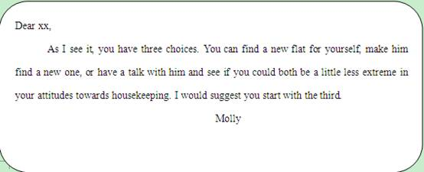
B
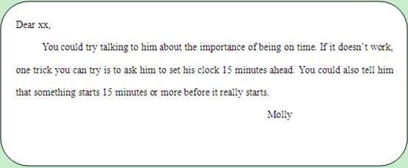
C
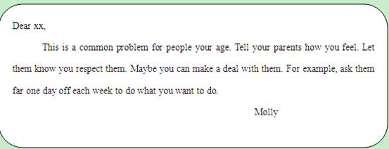
D
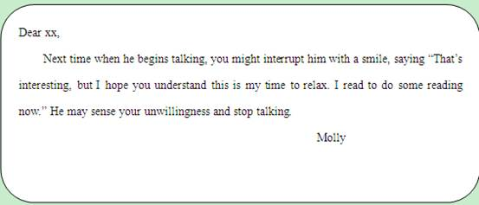
E
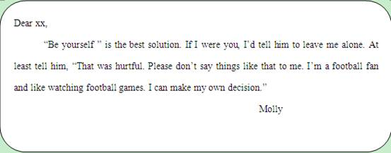

F
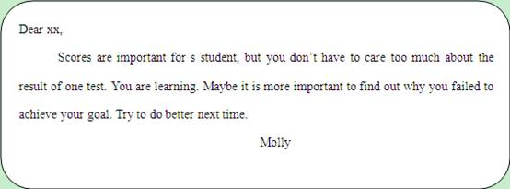

第Ⅱ卷 非选择题部分（共40分）
第四部分：写作（共两节，满分40分）
第一节 短文改错（共10小题；每小题1分，满分10分）
假如英语课上老师要求同学们交换批改作文，请你修改你同桌写的以下作文。文中共有10处语言错误，要求你在错误的地方增加、删除或修改某个单词。
增加：在缺词处加上一个漏字符号(∧)。
删除：把多余的词用斜线(\)划掉
修改：在错的词下划一横线，在该行下面写出修改后的词。
注意：1. 每处错误及其修改均仅限一词;
注： 只允许修改10处，多者(从11处起)不计分。
One should keep rules. And some people don’t. My neighbor Mr. smith is a person of such kind. He wouldn’t like to obey rules like most people in the public. For example, when he walks in the street, he walks in the left side while all the other keep right. In some places, there have notices such as “No Smoking” on the walls. But she has none of it. He lights his cigarette to show he is different with others. Though he doesn’t always obey rules, sometimes he had to. He has to bend his head while he goes through the gate with a notice“ Mind your head!”

第二节 书面表达（满分30分）
假设你是李华，你的同学杨帆报考他希望就读的大学，却屡次遭到拒绝。请你根据所给的信息，代表全班同学用英语给“中国日报”（China Daily）写封信，介绍杨帆的情况并呼吁全社会关心帮助残疾人。词数不少于120。
姓名: 杨帆 性别 男
学习 成绩优秀，英语突出，多次受到学校奖励
品质: 乐于助人，自信自强
问题：报考他希望就读的大学，却屡次遭到拒绝
希望: 残疾人应该拥有平等的受大学教育的权利，呼吁全社会关心帮助残疾人实现梦想。
Dear editor ,
______________________________________________________________________
______________________________________________________________________
______________________________________________________________________
______________________________________________________________________
______________________________________________________________________
______________________________________________________________________
______________________________________________________________________
______________________________________________________________________
______________________________________________________________________
______________________________________________________________________
______________________________________________________________________
______________________________________________________________________

Yours ,
Li Hua
高三第一次月考英语试卷 答 案
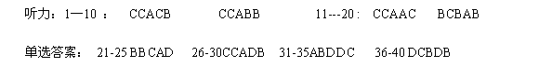
完形填空答案 ： 41C 42B 43D 44B 45C 46A 47B 48C 49D 50B 51A 52A 53D 54C 55B 56D 57C 58B 59A 60D
阅读理解答案 A篇BDCA B篇答案DBCD
C篇DABD D篇BBCA E篇CDBD

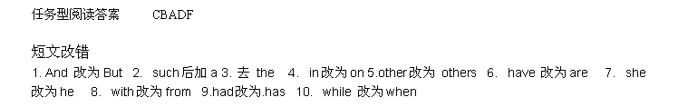
写作：
