杨府山寒假 英语作业二
第I卷
第一部分 听力（共两节，满分30分）
做题时，先将答案标在试卷上。录音内容结束后，你将有两分钟的时间将试卷上的答案转涂到答题纸上。
第一节（共5小题；每小题1.5分，满分7.5分）
听下面5段对话。每段对话后有一个小题，从题中所给的A、B、C三个选项中选出最佳选项，并标在试卷的相应位置。听完每段对话后，你都有10秒钟的时间来回答有关小题和阅读下一小题。每段对话仅读一遍。
1. Who is the woman?
A. A clerk B. A teacher C. A student
2. Why is the man feeling so hot?
A. The sun is shining stronger.
B. His car is giving off too much heat.
C. There is more pollution in the air.
3. How much will the man spend?
A. $ 25 B. $30 C. $40
4. When is the concert?
A. At 6:50 B. At 7:30 C. At 8:00
5. What are the speakers mainly talking about?
A. An idiom B. The Bible C. A show
第二节（共15小题；每小题1.5分，满分22.5分）
听下面5段对话或独白。每段对话或独白后有几个小题，从题中所给的A、B、C 三个选项中选出最佳选项，并标在试卷的相应位罝。听每段对话或独白前，你将有时间阅读各个小题，每小题5秒钟；听完后，各小题将给出5秒钟的作答时间。每段对话或独白读两遍。
听第6段材料，回答第6—7题。
6. What is the probable relationship between the speakers?
A. Friends B. Boss and employee. C. Teacher and student
7. When will the woman be available?
A. At 2:00 on Tuesday. B. At 3:30 on Thursday. C. At 5:00 on Thursday.
听第7段材料，回答第8至10题。
8. What does Nancy look like?
A. She is about 50 inches tall.
B. She has a white bag with her.
C. She is wearing a pink shirt with long hair.
9. Who might the man be?
A. A member of zoo staff. B. The woman’s colleague. C. A salesman.[来源:Z*xx*k.Com]

10. What will the woman do next?
A. Call the police. B. Go to buy a Coke. C. Wait for her daughter.
听第8段材料，回答第11至13题。
11. According to the man, why are arm exercises encouraged?
A. They can make your arms soft.
B. They can make your blood stable.
C. They can make you physically healthy.
12. How heavy is the man’s brother?
A. 95kg. B. 82kg. C. 65kg.
13. What type of exercise is also suggested by the doctors?
A. Leg exercises. B. Cycling. C. Yoga.
听第9段材料，回答第14至17题。
14. What is the relationship between the speakers?
A. Friends. B. Librarian and reader. C. Professor and student.
15. What does the man know about the article?
A. The written time. B. The title. C. The author.
16. Where is the article from originally?
A. A newspaper. B. A book. C. A website.
17. Why did the short list appear?
A. The man typed in some key words.
B. The man started his search well.
C. The man only entered some dates in the box.
听第10段独白，回答第18-20题
18. What will the temperature be tomorrow?
A. About eighty degrees. B. Around ninety degrees. C. In the low hundreds.
19. What does the speaker advise people to do?
A. Drink much water. B. Wear glasses. C. Keep children at home.
20. What will the weather be like next week?
A. Extremely hot. B. Cooler than this week. C. In the mid-sixties.
第二部分 阅读理解（共两节，满分35分）
第一节（共10小题；每小题2.5分，满分25分）
阅读下列短文，从每题所给的A、B、C和D四个选项中，选出最佳选项，并在答题纸上将该项涂黑。
A
Raised by a single mother in Hartford, Fred Wright struggled with behavioral problems and was forced to move from one school to another. He even reached a point where he felt like he had nothing to live for.
“I was walking around with a lot on my shoulders,” he said. “I couldn’t handle it. I didn’t care about life anymore.” But all that started to change when Wright met Patricia Kelly.
“I was seven when I met Mrs. Kelly. I wasn’t used to strictness. I wasn’t used to hearing the word ‘no’,” said Wright, now 17.
Kelly, a former soldier and an equestrian(骑手), took Wright under her wing and helped him find hope in an unlikely place—on a horse.
“Wright was like a round peg that everybody kept trying to squeeze into a square hole, “Kelly said. “He was hurting. He needed a place where he could express himself. The riding field became that place for him.”
For the last 30 years, Kelly has helped children stay on the right track through her non-profit, Ebony Horsewomen. The program offers horseback riding lessons and teaches animal science to more than 300 young people a year. By exposing those children to horsemanship, Kelly aims to give them an alternative to the streets and an opportunity to turn their lives around.
“We use horse as a hook to create pride, esteem and healing,” said Kelly, 66. “They learn that they have ability. They just have to unlock it.”
“When you teach children to ride horses, they learn they are the center of their environment,” said Kelly, “Once they make the connection, they can change what happens in school, at home and in the community.”
21. Why did Fred Wright have to move from one school to another?
A. Because his mother couldn’t afford the fees.
B. Because his parents got divorced.
C. Because he behaved badly at school.
D. Because he didn’t set a life goal.
22. How did Patricia Kelly help Fred Wright?
A. She provided him with a home. B. She exposed him to the riding field.
C. She found him a better school. D. She encouraged him to learn science.
23. What can be inferred from the last two paragraphs?
A. Horse riding is helpful to the growth of kids.
B. Patricia Kelly is a very successful woman.
C. Horses are closely related to the environment.
D. It is hard for a kid to learn to ride a horse.

B
Without proper planning, tourism can cause problems. For example, too many tourists can crowd public places that are also enjoyed by the people there. If tourists create too much traffic, the people there become angry and unhappy. They begin to dislike tourists and to treat them impolitely. They forget how much tourism can help the country’s economy. It is important to think about how tourism affects them. Tourism should help a country keep the culture and beauty that attract tourists. Tourism should be also helpful for the health and happiness of local people. Too much tourism can be a problem. If tourism grows too quickly, people must leave other jobs to work in the tourism industry. This means that other parts of the country’s economy can suffer.
On the other hand, if there is not enough tourism, people can lose jobs. Businesses can also lose money. It takes a great deal of money to build large hotels, airports, air terminals, first-class roads, and other support facilities needed by tourist attractions. For example, a major international class tourism hotel can cost as much as 50 thousand dollars per room to build. If this room is not used most of the time, the owners of the hotel will lose money.
Building a hotel is just a beginning. There must be many support facilities as well, including roads to get to the hotel, electricity, sewers to handle waste and water. All of these support facilities cost money. If they are not used because there are not enough tourists, jobs and money are lost.
24. Which of the following probably has been discussed right before this passage?
A. It is extremely important to develop tourism.
B. Building roads and hotels is essential.
C. Support facilities are highly necessary.
D. Planning is of great importance to tourism.
25. Not enough tourism will _____.
A. cause the prices to rise and the income to fall
B. lead to fewer tourist attractions
C. have more local people out of work
D. ruin other parts of the country’s economy
26．It can be inferred from the text that ________.
A. the author doesn’t like the tourism to develop quickly
B. tourism can make a difference to the country’s economy
C. local people don’t want to be disturbed by tourists
D. too many support facilities will lead to jobs and money loss

C
Cotton farmers in some Indian villages are busily buying Coca-Cola and Pepsi, believing that the sugar in the fizzy (起泡的) drinks kills pests.
Farmers say scientists advised them to mix pesticides with a sugary juice to control pests, and they found the mixture cheaper and more effective than pure chemicals---although soft drinks makers and scientists dismissed the remarks. N. Hamunayya, who has become a famous person in his village in the south-eastern state of Andhra Pradesh, said his crop survived an attack of pests which had resisted other pesticides. “We found that all the cola had a uniform effect on pests. The pests became dead and fell to the ground,” he said. He said the drinks had all the elements they needed: they were cheaper, sticky, fizzy, and attracted ants, which ate the young of the pests. But Thinupathi Reddy, assistant director of the Regional Agriculture Research Station, Guntur, says tests had proved such results wrong. “We conducted some field trials on cotton crop at our research station. There was no obvious productivity or destruction of pests,” he says.
Statements from Pepsi and Coca-Cola said there was “no scientific basis” for this practice. But their dealers are enjoying increasing sales. Mantan Wall, who sells soft drinks in 17 villages in the region, said sales rose up, thanks to the farmers. “For the 10 days between August and September I had successful business. Instead of just 30 cases (each containing a dozen one-litre bottles) of cola, I started selling almost 200 cases,” he said. “We expected the sales to drop after the news over pesticide residues (残留) in the cola drinks. Now I have to keep extra supply for the cotton farmers,” he said.
In February, an Indian environment group made a report saying drinks made by Coca-Cola and Pepsi contained pesticides and called for tougher safety standards. The US firms strongly rejected the findings of the New Delhi-based Centre for Science and Environment and said their products were safe.
27. What is the writer’s purpose of writing this passage ?
A. Introduce an incident that happened in India.
B. Warn people of the harmful effects of soft drinks.
C. Suggest using Coca-Cola and Pepsi to kill pests.
D. Announce a new discovery of some soft drinks.
28. According to paragraph 2, the drinks can kill pests because_____.
A. there is some pesticide left in them
B. they are cheaper, sticky and fizzy
C. they have all the elements that kill pests
D. they made pesticides more effective
29. What does the underlined part “this practice” in paragraph 3 probably refer to?
A. testing the mixture B. selling more drinks in India
C. mixing the drinks with pesticides D. attracting ants to eat the young pests
30. The drink makers wouldn’t accept the fact that their drinks could kill pests because_____.
A. they thought it went against science
B. they didn’t believe the farmers told the truth
C. they feared it might bring harm to their business
D. they insisted there was no poison left in their products
第二节（共5小题；每小题2分，满分10分）
根据短文内容，从短文后的选项中选出能填入空白处的最佳选项。选项中有两项为多余选项。
Personally, I believe that the female brain is mainly built for empathy—the ability to understand other people—and that the male brain is mainly built for building systems. 31 For example, women are more likely to read magazines on fashion and parenting, while men will choose magazines featuring computers and sport.
You may think that these preferences are influenced by the way people are taught to behave when they are growing up. However, this is not the case. A new study carried out at Cambridge University shows that newborn girls look longer at a face, and newborn boys look longer at a mobile. 32 It has also been observed that girls are better at noticing signs of changes in other people’s feelings. Boys, however, seem to enjoy building toy towers and playing with toys having clear functions. 33 People whose jobs are in the construction industries are almost male. Math and engineering, which require high levels of systems-thinking, are also male-chosen disciplines. Why do men and women have the difference? Actually women have four times as many brain neurons that connect the right and left part of their brains. Because of it, women have a better ability to multitask than men. 34 Men tend to focus on a limited number of problems at a time. They will separate themselves from problems and view tasks as independent from one another.
Some people may worry that I am suggesting one gender is better than the other, but this is not the case. My theory says that males and females differ in the kinds of things that they find easy, but that both genders have their strengths and weaknesses. 35 It is not true. The study simply looks at males and females as two groups, and asks what differences exist and why they are there.
A. Generally speaking, there are clear differences.
B. You can see the same kind of pattern in the adult workplace.
C. Their preference for building systems may change over time.
D. They will consider many sources of information at the same time.
E. It is important to stress that the female brain may be built more for empathy.
F. That suggests certain differences between male and female brains are biological.
G. Others may think the theory creates a belief of what a particular type of person is like.
第三部分 语言运用（共两节，满分45分）
第一节 完形填空（共20小题；每小题1.5分，满分30分〉[来源:Z#xx#k.Com]
阅读下面短文，从短文后各题所给的A、B、C和D四个选项中，选出可以填入空白处的最佳选项，并在答题纸上将该项涂黑。
Time talks. It speaks more plainly than words. Time 36 in many ways.
Consider the different parts of the day, for example. The time of the day when something is done can give a 37 meaning to the event. It is not a 38 to telephone someone very early in the morning. If you telephone him early in the day, 39 he is shaving or having breakfast, the time of the call shows that something is urgent and 40 immediate attention.
The same meaning is 41 telephone calls made after 11:00 pm. If someone receives a call during sleeping hours, he may think it is a 42 of life or death. The time chosen for the call 43 its importance.
In social life, time plays a very 44 part. In the United States, guests tend to feel they are not highly regarded if the 45 to a dinner party is extended only three or four days before the party date. But this is not 46 in all countries. In other areas of the world, it may be considered foolish to make an appointment too far 47 because plans which are made for a date more than a week away tend to be 48 .
The meaning of time 49 from place to place in the world. 50 , misunderstandings often arise between people from different cultures that 51 time differently. For example, promptness(准时) is 52 greatly in American life. If people are not prompt, they may be regarded as 53 or not fully responsible. In the US, no one would think of keeping a business partner 54 for an hour; it would be too rude. A person who is five minutes late is 55 to make a short apology. [来源:学科网ZXXK]
36. | A. wastes | B. runs | C. travels | D. communicates
37. | A. precious | B.ridiculous[来源:学+科+网Z+X+X+K] | C. special | D. rare
38. | A. deal | B.custom | C. problem | D. duty
39. | A. whenever | B. though | C. once | D. while
40. | A. requires | B. escapes | C. pays | D. gives
41. | A. compared with | B. covered with | C. devoted to | D. attached to
42. | A. matter | B. story | C. game | D. view
43. | A. reduces | B. ignores | C. stresses | D. doubts
44. | A. different | B. significant | C. small | D. equal
45. | A. plan | B. wish | C. gift | D. invitation
46. | A. useful | B. true | C. clear | D. grateful
47. | A. on time | B. at length | C. by chance | D. in advance
48. | A. forgotten | B. remembered | C. canceled | D. opposed
49. | A. rushes | B. separates | C. varies | D. keeps
50. | A. Meanwhile | B. Thus | C. Otherwise | D. Besides
51. | A. make | B. kill | C. treat | D. save
52. | A. valued | B. complained | C. seized | D. influenced
53. | A.helpless | B. desperate | C. impolite | D. unlucky
54. | A. working | B. waiting | C. approaching | D. thinking
55. | A. expected | B. forced | C. refused | D. blessed

第Ⅱ卷
第三部分 语言运用（共两节，满分45分）
第二节（共10小题；每小题1.5分，满分15分）
阅读下面材料，在空白处填入适当的内容（1个单词）或括号内单词的正确形式。
阅读下面材料，在空白处填入适当的内容（1个单词）或括号内单词的正确形式
Johnny: Hey! I’m practicing Tai Chi (太极). Would you like 56 (join) me?
Peter: I know 57 about it. Is it difficult?
Johnny: It seems easy, but you need a lot of practice. You just follow me like this.
Peter: OK. Don’t laugh 58 me. I may look funny.
Johnny: Bend your knees slightly and reach out your arms like tree branches, naturally and 59
(soft). Try to keep your body straight. More slowly, then be sure to keep your balance and
don’t let your body shake.
Peter: I cannot control my body well. My legs become 60 (pain).
Johnny: Keep 61 (hold) your position for a while. It helps develop your strength and
flexibility. Raise your leg and let it stay in the air for seconds.
Peter: I feel my legs shaking. I cannot do this any longer.
Johnny: Be patient! Tai Chi 62 (call) “shadow boxing” in English. It asks you to act like water: to
be flexible as well as strong. 63 real competition, a Tai Chi master borrows the
strength of the competitor and uses this energy to fight back. The harder you try to beat
him, the more likely you will get hit. He controls you!
Peter: Unbelievable! Oh… 64 you don’t mind, I’ll stop and take 65 deep breath.

第四部分 写作（共两节，满分40分）
第一节：应用文写作（满分15分）
假设你是李华，请根据以下四幅图的先后顺序，用英语写一篇周记，记述爸爸出差期间，妈妈生病，你照顾她的过程。
注意：1.周记的开头已经为你写好。
2.词数80左右。
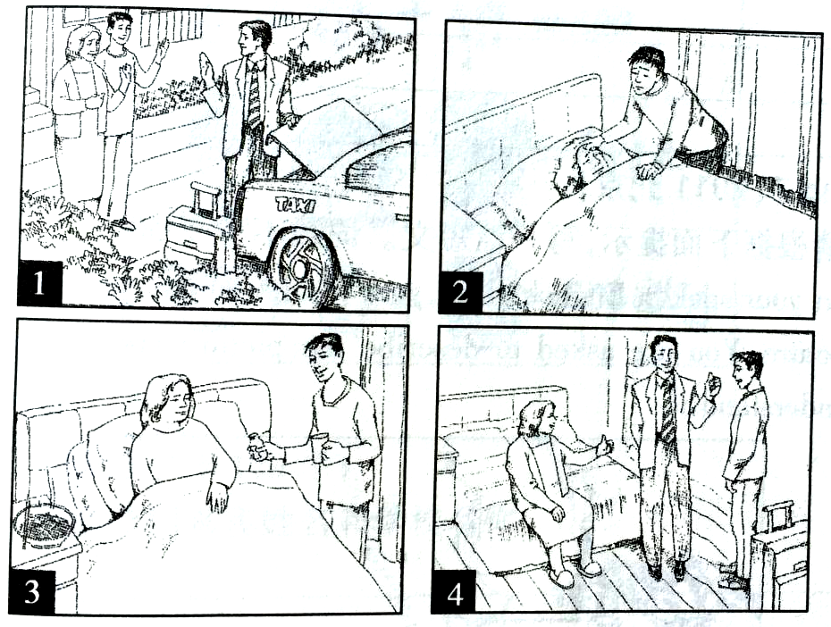
Last Monday, ____________________________________________________________
____________________________________________________________________________
第二节：概要写作（满分25分）
阅读下面短文，根据其内容写一篇60词左右的内容概要。
Many couples who already have one healthy, happy child, are facing a dilemma, that is, the issue of whether to have a second child or not. They have hard jobs and limited time and money, but they want to make sure that their only child does not become a lonely child. So, what are the advantages and disadvantages of having a second child? That is what so many couples are very much concerned about and eager to understand.
One popular saying is that one child means a lonely child. That’s why many single-child parents plan to have a second child. They feel guilty about their decision to have only one child, because there are no other children in the family for their only child to play with, which may make the child feel lonely at times, especially during vacations.
Another common argument against having just one child is that an only child may be more spoiled than one with brothers or sisters. If one couple had only one child, the child could not learn to share things with others and are less capable of getting along well with other children than one who grows up with brothers or sisters.
However, in many parts of the world, more and more parents are still choosing not to have a second child because they argue that there are advantages for the child as well as the parents. With just one child, they suggest, there is little chance of family arguments concerned with children. Besides, as an only child in the family, the child can receive more quality time and attention. This often leads to increased self-respect and independence, which can lead to the child being more confident.
Unluckily, there is no simple answer to the question of whether or not to have a second child. Every family is different, and what is proper for one family may not be for another. The important thing, in the end, is to make a decision that both you and your spouse (配偶) feel confident about.
答案
高三英语
I. 听力
1-5 ACBBA 6-10 CBAAC 11-15 CCBBC 16-20 AABAB
II.阅读理解
21-23 CBA 24-26 DCB 27-30 ADCC 31-35 AFBDG
III. 完形填空[来源:Zxxk.Com]
36- 40 DCBDA 41-45 DACBD 46-50 BDACB 51-55 CACBA
IV. 语法填空
- to join 57. nothing 58.at 59. softly 60. painful
- holding 62. is called 63. In 64. If 65. a
V. 应用文写作
Last Monday, my father said goodbye to my mother and me and went on a business trip. He would be away for three days. Just the next morning, I found my mother wasn’t feeling well. She had a cold. I immediately went to get her some medicine and then prepared some noodles for her. With my special care, my mother recovered quickly. When my father came back home, my mother told him what had happened. He praised me for what I had done.
I feel very happy that I have done something for my mother.
VI. 概要写作
Nowadays, whether to have a second child is a dilemma for many couples（要点1）. Some parents who support the idea believe with no one to play with, one child feels lonely and be more spoiled and can't get along with other children（要点2）. However, other parents choose not to do so for the advantages for both the child and the parents（要点3）. Actually, there is no simple answer to the question and the important thing is the couple's own confidence about decision（要点4）.

