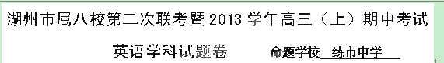
考生须知：
1、本试题卷分第Ⅰ卷(客观题)和第Ⅱ卷（主观题）两部分，试卷共10页；满分为120分；考试时间为120分钟。
2、第Ⅰ卷做在答题卡上，第Ⅱ卷做在答题卷上，做在试题卷上不得分。
第Ⅰ卷（共80分）
第一部分：英语知识运用（共两节，满分30分）
第一节：单项填空（共20小题，每小题0.5分，满分10分） 从A、B、C、D四个选项中，选出可以填入空白处的最佳选项，并在答题卡上将该项涂黑。
1. --- I need to advertise for a roommate for next term.
--- __________? Mary is interested.
A. So what B. What for C. How come D. Why bother
2. Nowadays people are more likely to go to ________ mall than visit the tailor when shopping for clothes, so tailors have adapted to _________ new reality.
A. the; a B. /; the C. the; the D. a; a
3. The story conveys a strong message, _________ that will hopefully touch all who read it.
A. it B. that C. those D. one
4. The water was now two feet deep, making it difficult, if not impossible, _________ the car out.
A. getting B. to get C. got D. get
5. --- I haven’t got the reference book yet, but I will have a test on the subject next month.
--- Don’t worry. You ________ have it by Thursday.
A. could B. may C. shall D. must
6. She would move quietly up to the sparrow on a small tree just to get a better look, her face __________ with childlike expressions at one of God’s simple wonders.
A. shone B. shining C. having shone D. being shone
7. Readers are required to _________ the rules of the library and mind their manners.
A. observe B. confirm C. review D. appreciate
8. --- It’s a shame that you missed the lecture on the British culture given by Thompson.
--- I _________ it, but I was busy preparing the coming exam.
A. attended B. had attended C. would have attended D. would attend
9. --- What on earth are the police busy with?
--- They have been investigating how the train crash __________.
A. came out B. came across C. came about D. came up
10. --- I hear that Jason is planning to buy a new car.
--- I know. By next month, he ________ enough for a used one.
A. has saved B. saves C. will be saving D. will have saved
11. --- Mr. Anderson is popular with his students, for he is kind, strict and knowledgeable.
--- No wonder he has such a good_________.
A. reputation B. tradition C. preference D. presentation
12. Don’t touch your eyes, nose and mouth, because they aren’t covered by skin and can ________ the virus easily.
A. pick up B. take up C. make up D. bring up
13. Two lawyers have donated $ 50, 000 to _________ our school’s campaign “Help the Needy”, which was started by our former headmaster 10 years ago.
A. approve B. advocate C. guarantee D. sponsor
14. Evidence has been found through years of study __________ children’s early sleeping problems are likely to continue when they grow up.
A. why B. how C. that D. whether
15. I’m always ________ about what I say because careless remarks are likely to hurt others’ feelings.
A. enthusiastic B. curious C. doubtful D. cautious
16. The young lady from Australia has a gift for creating an atmosphere for her students _________ allows them to communicate freely with each other.
A. where B. which C. what D. who
17. The engineer buries himself in work all day long and has no time for some outdoor activities, __________ he has the interest.
A. as if B. even if C. so long as D. now that
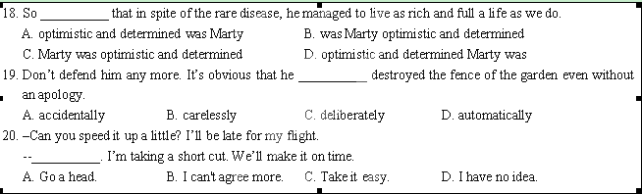
第二节 完型填空（共20小题；每小题1分，满分20分）
On a trip to California, my family stopped for lunch. As we walked toward the entrance to the restaurant, a man, with a 21 beard and dirty hair, jumped up from a bench outside the restaurant and opened the door for us．Regardless of his 22 , he greeted us in a friendly way.
Once inside, my daughters whispered, "Mom, he 23 . " After we ordered our lunch, I explained, telling the kids to look 24 the dirt. We then watched other customers approach the restaurant but many 25 him. Seeing this rudeness truly upset me. The day I became a mother, I had determined to set a good 26 to my children. Yet sometimes when things didn't go right, being a good example was 27 . When our meal arrived, I realized I had left the car-sick pills in the truck．With the windiest trip ahead, the kids needed them, so I 28 myself from the meal and went to get them.
Just then, the "doorman" was opening the door for a couple. They rushed past him without even acknowledging his 29 . Letting them in first, I said a loud "thank you" to him as I 30 .
When I returned, we talked a bit. He said he was not allowed inside 31 he purchased food. I went back and told my family his 32 .Then I asked our waitress to add one soup and sandwich.
The kids looked 33 as we had already eaten, but when I said the order was for the "doorman", they smiled. When it was time to 34 our trip, I found the "doorman" enjoying his meal. Upon seeing me, he stood up and thanked me heartily. He then 35 out his hand for a handshake and I gratefully accepted. I suddenly 36 the tears in his eyes—tears of gratitude. What happened next drew great astonishment: I gave the " doorman" a 37 . He pulled away, with tears 38 down his face.
Back in truck, I fell into deep thought．While we can't choose many things in life, we can choose when to show gratitude．I said thanks to a man who had 39 held open a door for me, and also said thanks for that 40 to teach my children by example.
21．A．messy | B．clean | C．pretty | D．bright
22．A．service | B．state | C．appearance | D．attitude
23．A．smokes | B．smells | C．sighs | D．smiles
24．A．around | B．over | C．beyond | D．into
25．A．ignored | B．hated | C．missed | D．refused
26．A．target | B．rule | C．record | D．example
27．A．stressful | B．accessible | C．awkward | D．tough
28．A．excused | B．refreshed | C．prevented | D．forgave
29．A．company | B．presence | C．challenge | D．attack
30．A．quitted | B．marched | C．exited | D．approached
31．A．before | B．unless | C．though | D．since
32．A．story | B．deed | C．desire | D．demand
33．A．concerned | B．puzzled | C．excited | D．bored
34．A．make | B．start | C．continue | D．take
35．A．waved | B．washed | C．raised | D．reached
36．A．watched | B．inspected | C．witnessed | D．noticed
37．A．hug | B．nod | C．lift | D．strike
38．A．slipping | B．rushing | C．rolling | D．breaking
39．A．firmly | B．simply | C．constantly | D．politely
40．A．journey | B. wisdom | C. community | D．opportunity

第二部分：阅读理解(共25小题，每小题2分，共50分)
阅读下列短文，从每题所给的四个选项（A、B、C和D）中，选出最佳选项，并在答题卡上将该项涂黑。
A
I believe in leaving work at five o’clock. In a nation with such a strict work ethic(道德规范) , this is considered strange. Working only 40 hours a week? I just don’t know many people who punch out (打卡下班) at five o’clock anymore.
My father tried to teach me the importance of hard work, long hours and devotion to a career. But then there are the things he taught me unintentionally, like when he arrived home from work for the last time and crawled up the stairs.
My father, a self-employed sales trainer, was that sick, that tired. His body was wracked with liver cancer, and he suffered the effects of a diabetic ulcer（糖尿病）. Despite all this, he insisted on traveling a long way to give a lecture. He probably earned a lot of money that day, but he paid the price. He returned to the hospital soon afterwards and was dead within three months, aged just 58.
It’s been 10 years since I saw my father come home that night and since then, I’ve thought a lot about work. I’ve decided something: I will never crawl up the stairs exhausted. As much as I love my job as a newspaper reporter, I will never work myself into the ground, physically or emotionally. Not taking my work home didn’t come easily to me at first. After all, I am my father’s daughter. In college, I was the girl who sat on the library steps each morning, waiting for the doors to open. I even dreamt about schoolwork.
My dad once told me he was unable to just gaze at a sunset; he had to be doing something as he looked at it—writing, reading, playing chess. You could say he was a success: He was a published author, an accomplished musician, fluent in many languages. That’s an impressive list, but the thing is I want to gaze at sunsets. I don’t want to meet a deadline during them or be writing a column at the same time, or glance at them over the top of a book.
This raises the question: If I leave work at five o’ clock to watch the sunset, what are the consequences? Do I risk not reaching the top of my profession? Maybe, because honestly, knocking off after eight hours probably won’t earn me the best promotion. But hey, leaving work at five o’ clock means I eat dinner with my family. I get to hop on my bike and cycle through the streets of my hometown when there is no traffic.
And I get to take in a lot of sunsets. That’s got to be worth something.
41. Which of the following about the author’s father is true?
A. He set a good example to his daughter.
B. He tried to force his values on his daughter.
C. He gained much pleasure from his work.
D. He achieved great success at the expense of his health.
42. What does the author mean by saying “Not taking my work home did not come easily at first” in Paragraph 4?
A. There was so much work to do. B. All her colleagues took work home.
C. She was educated to be a workaholic. D. She wanted a promotion in her work.
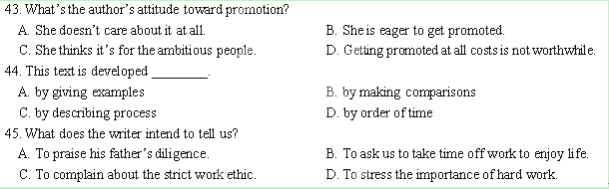
B
Have you ever considered all the English expressions that include words about clothes? Let’s see if I can name a few proverbs “off the cuff” since I haven’t prepared for it.
English expressions with “pants”
People wear pants to cover the lower part of their bodies. We sometimes say that people who are restless or nervous have “ants in their pants.” They might also “fly by the seat of their pants” -- they use their natural sense to do something instead of their learned knowledge. Sometimes, people may “get caught with their pants down” -- they are found doing something they should not be doing. And, in every family, one person takes control. Sometimes a wife tells her husband what to do. Then we say “she wears the pants in the family.”
When people want to say something about money
Pants usually have pockets to hold things. Money that is likely to be spent quickly can “burn a hole in your pocket.” Sometimes you need a belt to hold up your pants. If you have less money than usual, you may have to “tighten your belt” -- you may have to live on less money and spend your money carefully. But once you have succeeded in budgeting your money, you will have that skill “under your belt.”
I always praise people who can save their money and not spend too much. I really “take my hat off to them.” Yet, when it comes to my own money, I spend it “at the drop of a hat” -- immediately, without waiting. And sadly, you cannot “pull money out of a hat” -- you cannot get money by inventing or imagining it.
English expressions with “shoes”
Boots are a heavy or strong kind of shoes. People who are “too big for their boots” think they are more important than they really are. I dislike such people. I really do. You can bet your boots on that!
Yet, truly important people are hard to replace. Rarely can you “fill their shoes” -- or replace them with someone equally effective.
English expressions with “shirt”
My father is an important person. He runs a big company. He wears a suit and tie and a shirt with sleeves that cover his arms. Some people who do not know him well think he is too firm and severe. They think he is a real “stuffed shirt.” But I know that my father “wears his heart on his sleeve” -- he shows his feelings openly. And, he knows how to “keep his shirt on” -- he stays calm and never gets angry or too excited.
46. What is this passage mainly about?
A. How to say English correctly and properly.
B. Why English expressions include words about clothes.
C. Which words can be used to describe my father.
D. What people mean when they use some proverbs.
47. Which of the following proverbs are not related to money?
A. tighten one’s belt B. burn a hole in one’s pocket
C. get caught with their pants down D. take one’s hat off to them
48. Tim often considers himself the most important person in the world, which is far from the truth. We may say __________.
A. he is “too big for their boots”. B. he “bet his boots on that”.
C. he “fill their shoes”. D. he “wears his heart on his sleeve”.
49. If you want to praise somebody for his calmness when facing danger, you may say__________.
A. “You really fill your shoes.”
B. “Awesome! You wear your heart on your sleeve!”
C. “Amazing! How can you keep your shirt on at that time!”
D. “Cool! You are truly a stuffed shirt”.
C
Mom was right! If you say thank you, for even the smallest gift or slightest show of kindness, you’ll feel happy.
Gratitude, says Robert A. Emmons, a professor of psychology at the University of California, is an important element of happiness. In his recent book, Thanks!, Emmons uses the first major study on gratitude to prove mom’s point.
As one of the leading scholars of the positive psychology movement, he admits gratitude may be difficult to express. He advises you to begin by admitting that life is good and full of events and elements that make daily existence a wonder. Second, recognize that the source of life’s goodness is more than just you. That source may be your mom, a friend, partner, child, colleague at work or play.
Gratitude is always other-directed, notes Emmons. You can be pleased or angry with yourself and feel guilty about doing something wrong, but you can never be grateful to or for yourself.
Expressing gratitude shouldn’t be a reaction; it should be a state of mind. To feel grateful when life is a breeze and you have more than you need is easy. To feel grateful in time of crisis—anger, hatred and bitterness—is easier. Also, too many people are aware of life’s blessings only after these are lost.
It’s crisis and chaos—danger, disease, disability and death—that bring many individuals to realize just how dependent they are on others. Yet it’s the way each of us begins life and ends it. It’s too bad that so many people waste those decades in between laboring under the illusion(幻觉) they are self-sufficient, says Emmons.
The abundance of voices expressing gratitude from his studies of individuals with chronic health problems is many. But Emmons goes beyond his “groundbreaking” science to make his case for gratitude by including the inspirational writings of philosophers, novelists and saints, as well as the beliefs of various religious and their respective scripture(经文). Taken together, these observations are summed up quite nicely by famous humanist Albert Schweitzer, who said the secret of life is “giving thanks for everything”.
To enable and embrace gratitude, Emmons encourages the readers of Thanks! to keep a gratitude diary. He even provides easy-to-follow directions on how to practise and develop gratitude.
I’m not a reader or advocate of self-help books, but I am thankful for the reference I found in a newspaper article to the research Emmons was conducting on gratitude involving organ donors and recipients. The chance discovery led me to this book.
Mom implied that kindness seems to find its way back to the giver because life really is all about giving, receiving and repaying. So I’ll pay attention to her professional advice and say: Thank you, professor Emmons.
50. What is the text mainly discussed?
A. There are many ways of being thankful. B. Gratitude is important to happiness.
C. Mom is great for her being thankful. D. Being thankful will keep you fit.
51. The author mentions Robert A. Emmons’ book Thanks! in order to prove that __________.
A. Professor Emmons supports mom’s study on psychology.
B. mom is as great a psychologist as Professor Emmons.
C. Professor Emmons is a famous psychologist.
D. mom is right about her viewpoint on gratitude.
52. It will be easier for you to feel grateful when___________.
A. you live a comfortable life B. you receive gifts on your birthday
C. you get help during your hard times D. you are congratulated on your success
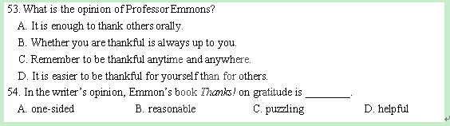
D
I met him first in 1936. I rushed into his ugly little shop to have the heels of my shoes repaired. I waited when he did it. He greeted me with a cheerful smile. “You’re new in this neighborbood, aren’t you?”
I said I was. I had moved into a house at the end of the street only a week before.
“This is a fine neighborhood,” he said. “You’ll be happy here.” He looked at the leather covering the heel sadly. It was worn through because I had failed to have the repair done a month before. I grew impatient, for I was rushing to meet a friend. “Please hurry,” I begged.
He looked at me over his spectacles. “Now, lady, we won’t be long. I want to do a good job. You see, I have a tradition to live up to.”
A tradition? In this ugly little shop that was no different from so many other shoe repair shops on the side streets of New York?
He must have felt my surprise, for he smiled as he went on. “Yes, lady, I inherited a tradition. My father and my grandfather were shoemakers in Italy, and they were the best. My father always told me, ‘Son, do the best job on every shoe that comes into the shop, and be proud of your fine work. Do that always, and you’ll have both happiness and money enough to live on.’”
As he handed me the finished shoes, he said: “These will last a long time. I’ve used good leather.”
I left in a hurry. But I had a warm and grateful feeling. On my way home I passed the little shop again. There he was, still working. He saw me, and to my surprise he waved and smiled. This was the beginning of our friendship. It was a friendship that came to mean more and more to me as time passed.
Every day I passed his shop, we waved to each other in friendly greeting. At first I went in only when I had repair work to be done. Then I found myself going in every few days just to talk with him.
He was the happiest man I’ve ever known. Often, as he stood in his shopwindow, working at a pair of shoes, he sang in a high, clear Italian voice. The Italians in our neighborhood called him la luce alla finestra—“the light in the window”.
One day I was disappointed and angry because of poor jobs some painters had done for me. I went into his shop for comfort. He let me go on talking angrily about the poor work and carelessness of present-day workmen. “They had no pride in their work,” I said. “They just wanted to collect their money for doing nothing.”
He agreed. “There’s a lot of that kind around, but maybe we should not blame them. Maybe their fathers had no pride in their work. That’s hard on a boy. It keeps him from learning something important.” He waited a minute and said “Every man or woman who hasn’t inherited a prideful tradition must start building one.”
“In this country, our freedom lets each of us make his own contribution. We must make it a good contribution. No matter what sort of work a man does, if he gives it his best each day, he’s starting a tradition for his children to live up to. And he is making lots of happiness for himself.”
I went to Europe for a few months. When I returned, there was no “light in the window”. The door was closed. There was a little sign: “Call for shoes at shop next door.” I learned the old man had suddenly got sick and died two weeks before
I went away with a heavy heart. I would miss him. But he had left me something—an important piece of wisdom I shall always remember: “If you inherited a prideful tradition, you must carry it on; if you haven’t, start building one now.”
55. The shoemaker looked sadly at the shoes because __________
A. they were of poor quality. B. he didn’t have the right kind of leather
C. he thought they were too worn to be repaired D. the author hadn’t taken good care of them.
56. The author was surprised when she heard that the shop had a tradition because the shop ________.[]
A. looked no different from other shoe repair shops B. had a light in the window
C. was at the end of a street D. was quite an ugly and dirty one
57. What does the underlined word “inherit” mean in paragraph 6 mean?
A. develop B. receive C. learn D. appreciate
58. The author later frequently went into the little shop __________.
A. to repair her worn shoes B. only to chat with the shoemaker
C. to look at the new shoes there D. only to get comfort from the shoemaker
59. Why was the shoemaker called “the light in the window” by his neighbors?
A. Because he always worked late at night. B. Because he always put a light in the window.
C. Because he was always guiding the others. D. Because he was always happy and cheerful.
60. What’s the best title of this passage?
A. A Proud Shoemaker B. A Prideful Tradition
C. The Light in the Window D. Treasure Your Shoes

第二节：下面文章中有5处（第61-65题）需要添加小标题。请从以下选项（A、B、C、D、E和F）中选出符合各段意思的小标题，并在答题纸上将相应选项的标号涂黑。选项中有一项是多余选项。
A. Enjoy the little things.
B. Get moving.
C. Be a social butterfly.
D. Don't get yourself down by stress.
E. Get your funny bone.
F. Keep a journal.
Secrets of People Who Never Get Sick
How do some friends survive every winter without even catching a cold? Some experts believe that they boost their immunity through simple lifestyle habits. Let’s steal their strategies and stay healthy all winter long.
61. _________________
It’s long been known that friendship is good for your health. In fact, people with six or more types of relationships in their lives were 25% less likely to get sick than those with three or fewer. It’s possible that people with varies social networks have diverse perceptions of themselves—as a co-worker, friend or community member. That boosts self-esteem and makes it easier to avoid stress. As a result, these people tend to stay healthier. Steal this secret: Be open to meeting new people; go to new events and reestablish old friendship.
62. _________________
Research has found that moderate exercise can improve immune function and build up resistance to colds and infections. On study of 36 overweight women, conducted at Loma Linda University, in California, found that those who walked quickly for 45 minutes 5 days a week reported half the number of days with cold symptoms during a 15-week period as their sedentary(久坐的) counterparts. Steal the secret: Aim for 40 to 45 minutes of moderate exercise, such as brisk walking, cycling, swimming or light running, at least five days a week.
63. _________________
Numerous studies have found that writing about a difficult or painful event not only accelerates the process of coping with it, but also can improve your physical health. When people write about upsetting or distressing experiences, it helps them judge the events more sensibly, understand them better and move on. Steal the secret: set aside twenty minutes a day for three successive days to write about the things that are most important to you now and how they’re affecting you.
64. _________________
Even small pleasures—having friends over for dinner, playing with your kids in the backyard or going to a concert—can boost your immune system. In fact, according to research at the State University of New York, positive events have a better effect on immune function than negative events. Steal this secret: Make time for yourself. Start devoting at least half an hour a day to talking to a friend, reading a book or indulging in your favorite activity. Think of it as preventive medicine.
65. __________________
Experts know that pressure increases the chance of catching the cold. The reason? Your body’s helper—T cells, which are key to defending against viruses, become weakened when you’re worn out. Steal the secret: Do some problem-solving. First, take a hard look at the situation and really consider whether you can do anything to change things. If you conclude that you can’t change that situation, try to change your physical and emotional reactions to it. Engaging in meditation, yoga or deep-breathing exercises and listing to calming music also help relieve stress.

第Ⅱ卷（共40分）
第三部分：写作 (注意：此部分写在答题卷上)
第一节 短文改错（共10小题；每小题1分，满分10分）
增加：在缺词处加一个漏字符号（^），并在其下面写上该加的词。
删除：把多余的词用斜线（/）划掉。
修改：在错的词下划一横线，在该词下面写出改正后的词。
注意：1. 每处错误及其修改均仅限一词；
2. 只允许修改10处，多者（从第11处起）不计分。

I can’t swim so I have a strong fear of water. Look back at my childhood, I think that three reasons might explain fear. Firstly, I am not allowed to go near the water when I was a child, as my mother had an unreasonable fear of it. Therefore, I was taught to see to the water as something danger. Secondly, my eyes became bad when I was five. If I took off my glass in the water, I couldn’t see something, and this increased my fear. What’s worse, for a child I once saw a neighbor drowned. Since then I have been more frightening.

第二节 书面表达（满分30分）
我们身边有很多的人对我们影响甚大，其中不乏有老师或朋友在你困难的时候帮助你，请结合你自己的一次经历谈谈你对朋友或老师在你人生道路上的重要性。写一篇100-120词左右的短文。
湖州市属八校第二次联考暨2013学年高三（上）期中考试
英语学科答案
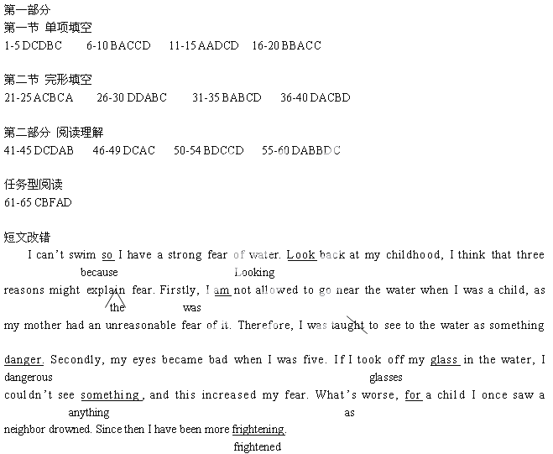
写作范文：

